Meeting Called to Order @ 5:34
Roll Call
Present: David Taber, Patrick Love, Michael Lane, Joshua Binning, Javier Cruz
Attending via Zoom: Joshua Matthews
Absent: Dr. Lippitz
Public Comment
None
Review of May 14, 2025 Minutes
Minutes approved
New Administrators
Kelly Jones, Dean of School Culture & Melanie Costello, Dean of Operations (new position)
Glows
Ellis- August Professional Development Institute was strong, differentiated for staff new/returning, set a strong tone for the year
Oliver- Back in School Bash was well attended- built culture and relationships, more than 250 family members attended
Hildreth- Community Circle has improved and is improving the UA culture
Jones- Paraprofessional have been trained more this year, they are feeling better prepared
Costello- Experiential Learning is going well and instructors are staff are invested in and enjoying the experience
Scholar Spotlight
Taniya Robinson-Ross discussed her experience with the Amigo de las Americas program and how it increased her confidence in her abilities.
Staffing Update (Kettelhut)
78.5% of staff returned for the 2025-26 school year
3 positions are currently open: EOW Receptionist, Scholar Aide, Teaching Assistant
Financial Reports (Lane)
Financials through July 2025
Expenses through July were reviewed, running a deficit at the moment of 400,000, but that is because new payments haven’t come through. We will be cash flush in October again.
Renovations at the UA in the bathrooms were completed.
Academic Update- (Ellis, Hildreth)
Initial IAR data was reviewed.
32% overall in ELA
12% overall in Math
15% overall in Science
Math- 9.8% last year 12.1% this year
ELA- 19.2% last year and 32% this year
Strategies & Initiatives
Differentiated PD & Support
Experiential Learning
OPAL
Compass pilot with Anet
MTSS/Branching Minds
Attendance Goals 2025-26 (Oliver)
Goal to increase attendance by 4.12% during the 2025-26 school year. (88 93)
Currently at 92.7%
Enrichment Update (Nicholson)
Summer Trips and Programs were reviewed
114 scholars (64 individual scholars + 7 alumni)
Enrollment Report (Kettelhut)
383 (380 last year) enrollment at the beginning of the year- currently at 385
1, 4, 5, 6, 7 are full (98.2%)
Re-Chartering Update (Boeddeker)

Charter Renewal Overview (FY26 Cycle)
Charter Agreement expires June 30, 2026
Renewal is evidence-based and central to Board role
Two components: Renewal Application + Renewal Site Visit (RSV)

Renewal Timeline (FY26)
April 1, 2025 – Renewal Application posted
August 1, 2025 – Renewal Application due
August 2025 – RSV scheduled
October 2025 – RSV conducted (October 1-3)
December 2025 – Final RSV reports published
February 2026 – Recommendations & renewal packets presented to RPS Board
July 1, 2026 – New charter cycle begins

Renewal Site Visit (RSV)
Independent, summative evaluation
Conducted by SchoolWorks + district team
Evidence: classroom visits, document reviews, focus groups
Ratings aligned to SchoolWorks Quality Criteria (SQC)
Outcome: Oral debrief + written report (findings only)

Four Domains of Evaluation (SQC)
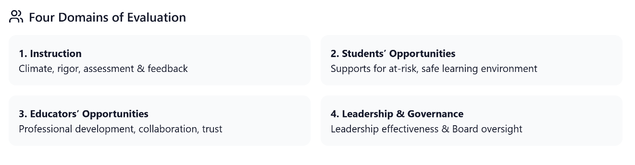

Board’s Role in Renewal
Participate in Governance/Board focus group during RSV
Demonstrate oversight in: Academic Program, Financial Stewardship, Legal & Ethical Compliance

Governance Focus Group Questions

Domain 2: Students’ Opportunities to Learn

- Describe the measures the school board has put in place to ensure the safety of students and staff.
  - Investment in security personnel or equipment
  - Training for staff and students

Domain 4: Governance & Leadership
2. Describe how the board oversees the school.
- Information received about the academic program (and ability to interpret it)
- Information received about the school’s finances (and financial expertise)
- Communication with school leader and/or CMO/EMO
- Recruitment, hiring, and evaluation of chief executive
- Oversight of contract with CMO/EMO
- Strategic plan

- How do you ensure effective operations at the school?
  - School budgeting process
  - Spending priorities
  - Staffing and deployment of human resources

- What measures have you put in place to ensure the sustainability of the school?
  - School leadership pipeline
  - Financial viability
  - Facilities
  - Self-assessment of governing practices and outcomes

Meeting Adjourned @
Reminders
- Board Trainings

------------------------------------------------------------------------------------------------------------------------------
Galapagos Rockford Charter School is dedicated to preparing scholars to be responsible, productive, college-educated adults capable of adapting and prospering in the changing global economy.
Core Values of Galapagos: Grit Drive Growth Mindset
Next Board Meeting: December 12, 2025 at Lower Academy- 2605 School St.
--------------------------------------------------------------------------------------------------------------------------------------------------

