July 14, 2020
Dear Parent/Guardian,

If you wish to have transportation provided for your scholar, please check this box

Rockford Public Schools plans to provide transportation for scholars starting August 26th, 2020. This is a partnership between RPS 205 and our scholars and families. We need help and support from our families to keep our scholars and staff safe.

The RPS driver pool is limited, and also limited on the number of scholars on each bus. It’s possible a bus will not be available at all times. If parents/guardians can find alternative transportation for their scholars, please do so. This will help families who have no other transportation options. If a bus route is changed or canceled, parents/guardians will be notified as soon as possible.

There are several new requirements and safety guidelines from the Illinois Department of Public Health and the Illinois State Board of Education because of the COVID-19 pandemic response. For a scholar to board the bus, parents/guardians must confirm each day that their scholar is free of any COVID-19 symptoms and has not been in contact with someone with COVID-19. To board the bus, scholars must:
- Wear a face covering to cover both the mouth and the nose.
- Carry an extra mask in case one is lost.
- Load the bus from back to front.
- Sit in an assigned seat.
- Sit two per seat. No more than 48 scholars will be assigned to each bus.

If your scholar shows signs of illness – such as flu-like symptoms, a persistent cough, fever, or other symptoms related to a cold or flu – your scholar must not come to school. If your scholar shows signs of illness at school, a parent/guardian must be available to take them home from school. Again, this is to keep our scholars and staff safe.

If your scholar is to be picked/dropped off at a sitter, which is a different address than you have on file, please check the box and fill out the form below.
* Please note, sitter request must adhere to the District’s sitter policies and are not guaranteed)
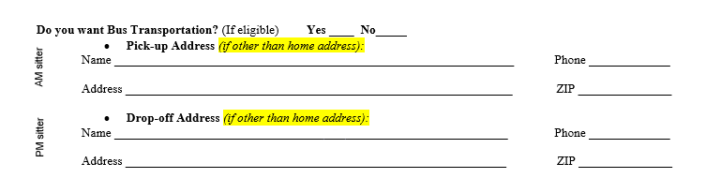

By printing your name and signing this document, the parent/guardian agrees to the above requirements and understands that RPS 205 will not provide transportation to scholars who do not comply with these requirements.

Please return this form by July 26th to:
By mail or drop off (8 am – 4 pm, Monday-Friday):
Galapagos Rockford Charter School
2605 School St.
Rockford, IL, 61101

Or by E-Mail: Aurora Schnorr at aschnorr@galapagoscharter.org

Thank you for your cooperation and understanding.

Electronic signatures are not valid.
This form must be signed in person and returned to address or email indicated above.

I, ___________________________________ request RPS 205 bus transportation for my scholar,
Print Parent/Guardian Name

__________________________________ during the COVID-19 pandemic period. I agree to the
Print Scholar Name

mandatory requirements for boarding the bus and understand that failure to abide by the
requirements will result in no transportation for my student until the requirements are met.

_______________________________________________ Date______________________
Parent/Guardian Signature

