Shirt
- GRCS polo (short or long sleeved)-available for purchase on our web site at: www.galapagoscharter.org click on the shop tab.

- Unmarked, neutral short sleeve shirts may be worn under uniform shirts.
- Uniform shirts must be tucked in upon entering the school building.

Pants
- Black dress pants- Please see the approved black pant and shoe options on the back of this letter.
(Black jeans, yoga pants, running pants or leggings are NOT permitted.)
- Black belt with a traditional buckle and no decoration
(optional for K-4 mandatory for 5-8)
- Shorts and skirts are not permitted at any time during the school year.

Shoes
- Black shoes, closed-toe shoes
- Soles and shoelaces must be all black

Store | Brand | Examples
Kohls  www.kohls.com | Amy Byer Dress Pants  Elle  Dockers  Chaps  Converse  New Balance  Sketchers  Prices range from $30-$70 | 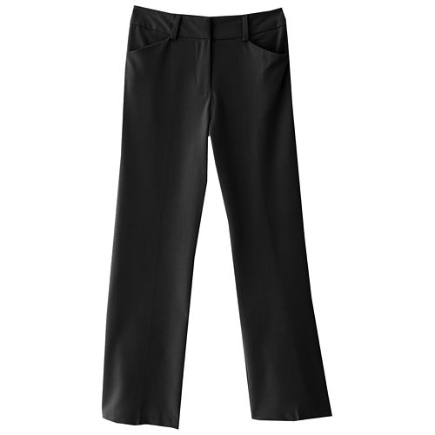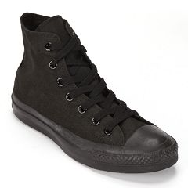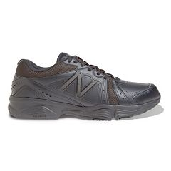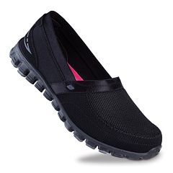
Old Navy  www.oldnavy.com | Girls Uniform Pants $19.99  Boys Uniform Pants $24.99  Ballet Flat $18.00 | 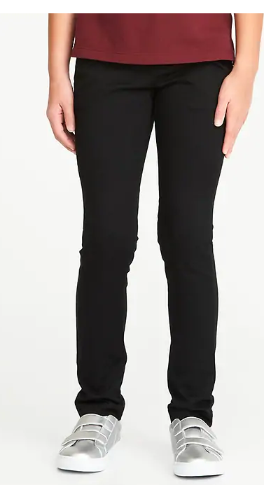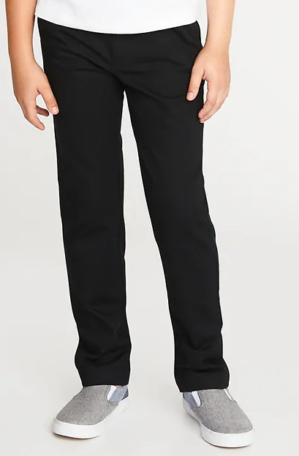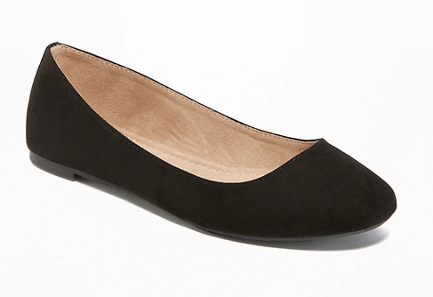
Walmart  www.walmart.com | George Uniform Pants  Me to Flynn Ballet Flats  Vans Old Skool  Sketchers  Prices range from $10-$50 | 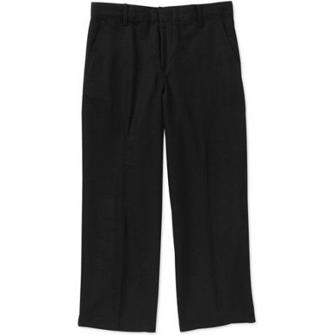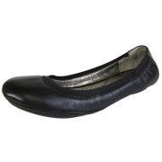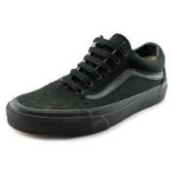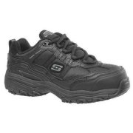
Target  www.target.com | Dickies Straight Pants $19.99  Twill Uniform Chinos $12.99  Ballet Flat $27.99  Boys’ Dress Shoes $19.99 | 